Supplementary Materials
Table of Contents
Inclusion and exclusion criteria 2
Supplementary Table 1: Quality assessment of studies using the Newcastle-Ottawa scale (NOS) 3
Supplementary Table 2: Quality assessment of studies using Grading of Recommendations, Assessment, Development and Evaluation (GRADE) approach 6
Supplementary Figure 1: Meta-regression of age and mean difference in corrected QT interval (QTc) by Bazett formula 7
Supplementary Figure 2: Meta-regression of duration of anorexia nervosa (AN) and mean difference in corrected QT interval (QTc) by Bazett formula 8
Supplementary Figure 3: Meta-regression of body mass index (BMI) and mean difference in corrected QT interval (QTc) by Bazett formula 9
Supplementary Figure 4: Meta-regression of heart rate (HR) and mean difference in corrected QT interval (QTc) by Bazett formula 10
Supplementary Figure 5: Forest plot of the QTc subgroup analysis categorized by AN severity based on BMI (mild: >17kg/m²; moderate: 16-16.9 kg/m²; severe: 15-15.9 kg/m²; extreme <15kg/m²) 11
Supplementary Figure 6: Forest plot of the QTc subgroup analysis categorized by age (above or below mean age of 19.7 years) 12
Supplementary Figure 7: Forest plot of the QTc subgroup analysis categorized by continent 13
Supplementary Figure 8: Forest plot of the QTc subgroup analysis categorized by antipsychotic use 14
Supplementary Figure 9: Forest plot of the QTc subgroup analysis categorized by heart rate 15
Supplementary Figure 10: Forest plot of the QTc subgroup analysis categorized by clinical setting 16
Supplementary Figure 11: Forest plot of the QT dispersion subgroup analysis categorized by body mass index (BMI) 17
Supplementary Figure 12: Forest plot of the QTc dispersion subgroup analysis categorized by body mass index (BMI) 18
Supplementary Figure 13: Funnel plot of the studies comparing corrected QT interval (QTc) calculated by Bazett formula of anorexia nervosa patients and controls 19

Inclusion and exclusion criteria
Inclusion Criteria | Exclusion Criteria
- Confirmed diagnosis of anorexia nervosa  - Measurement of QTc interval  - All genders  - All populations in all countries  - English language full text available or with English translations  - Published in peer-reviewed journal | - Animal studies  - Wrong study design (e.g., literature review; case report; RCT; systematic review; meta-analysis)

Supplementary Table 1: Quality assessment of studies using the Newcastle-Ottawa scale (NOS)
Author, year | Selection |  |  |  | Comparability | Exposure |  |  | NOS Score /9
 | Is the case definition adequate? | Representativeness of the cases | Selection of Controls | Definition of Controls | Comparability of cases and controls | Ascertainment of exposure | Same method of assessment for cases and controls | Non-Response rate
Green et al. 2020 | 0 | 0 | 1 | 1 | 1 | 0 | 1 | 1 | 5
Janzen et al. 2020 | 1 | 1 | 1 | 1 | 2 | 0 | 1 | 1 | 8
Krantz et al. 2020 | 1 | 0 | 1 | 1 | 2 | 0 | 1 | 1 | 7
Janzen et al. 2019 | 1 | 1 | 1 | 1 | 2 | 1 | 1 | 1 | 9
Frederiksen et al. 2018 | 1 | 0 | 1 | 1 | 2 | 1 | 1 | 1 | 8
Bomba et al. 2017 | 1 | 0 | 1 | 1 | 2 | 1 | 1 | 1 | 8
Padfield et al. 2016 | 1 | 0 | 1 | 1 | 2 | 1 | 1 | 1 | 8
Ertugrul et al. 2015 | 1 | 1 | 1 | 1 | 2 | 1 | 1 | 1 | 9
Billeci et al. 2015 | 1 | 0 | 1 | 1 | 2 | 0 | 1 | 1 | 7
Yahalom et al. 2013 | 1 | 1 | 0 | 1 | 1 | 0 | 1 | 1 | 6
Nussinovitch et al. 2012 | 1 | 1 | 1 | 1 | 2 | 0 | 1 | 1 | 8
Zulal et al. 2006 | 1 | 0 | 1 | 1 | 2 | 1 | 1 | 1 | 8
Facchini et al. 2006 | 1 | 0 | 0 | 1 | 2 | 1 | 1 | 1 | 7
Roche et al. 2005 | 1 | 0 | 1 | 1 | 2 | 0 | 1 | 1 | 7
Olivares et al. 2005 | 1 | 0 | 1 | 1 | 2 | 1 | 1 | 1 | 8
Krantz et al. 2005 | 1 | 0 | 0 | 1 | 2 | 1 | 1 | 1 | 7
Takimoto et al. 2004 | 1 | 0 | 1 | 1 | 2 | 1 | 1 | 1 | 8
Roche et al. 2004 | 1 | 0 | 1 | 1 | 2 | 1 | 1 | 1 | 8
Vasquez et al. 2003 | 1 | 0 | 1 | 1 | 2 | 0 | 1 | 1 | 7
Galetta et al. 2003 | 1 | 0 | 1 | 1 | 2 | 0 | 1 | 1 | 7
Galetta et al. 2002 | 1 | 0 | 1 | 1 | 2 | 0 | 1 | 1 | 7
Franzoni et al. 2002 | 1 | 0 | 1 | 1 | 2 | 1 | 1 | 1 | 8
Biadi et al. 2001 | 1 | 0 | 1 | 1 | 2 | 1 | 1 | 1 | 8
Panagiotopoulos et al. 2000 | 1 | 1 | 1 | 1 | 2 | 1 | 1 | 1 | 9
Durakovic et al. 1994 | 1 | 0 | 0 | 1 | 0 | 0 | 1 | 1 | 4
Borgia et al. 2021 | 1 | 0 | 1 | 1 | 2 | 1 | 1 | 1 | 8
Frederiksen et al. 2021 | 1 | 0 | 1 | 1 | 0 | 1 | 1 | 1 | 6
Dinardo et al. 2022 | 1 | 0 | 1 | 1 | 2 | 1 | 1 | 1 | 8
Studies categorized according to NOS as follows: 0-3 = Poor quality, 4-7 = Fair quality, 8-9 = Good quality.

Supplementary Table 2: Quality assessment of studies using Grading of Recommendations, Assessment, Development, and Evaluation (GRADE) approach
Certainty assessment |  |  |  |  |  |  | № of patients |  | Effect |  | Certainty | Importance
№ of studies | Study design | Risk of bias | Inconsistency | Indirectness | Imprecision | Other considerations | AN | Control | Relative  (95% CI) | Absolute  (95% CI)
Mean QTc (Bazetts)
26 | observational studies | not serious | very seriousª | not serious | not serious | None | 2084 | 4049 | - | MD 5.55 higher  (2.38 lower to 13.48 higher) | ⨁◯◯◯  Very low
Mean QTc (Hodges)
3 | observational studies | not serious | serious^{b} | not serious | not serious | none | 501 | 194 | - | MD 1.33 higher  (13.90 lower to 19.23 higher) | ⨁◯◯◯  Very low
Mean QTc (Fridericia)
4 | observational studies | not serious | very serious^{c} | not serious | not serious | None | 1368 | 3258 | - | MD 2.66 higher  (21.63 lower to 27.77 higher) | ⨁◯◯◯  Very low
Mean QTc (Framingham)
2 | observational studies | not serious | serious^{d} | not serious | not serious | none | 63 | 78 | - | 15.9 higher  (0.03 higher to 31.78 higher) | ⨁◯◯◯  Very low
QT Dispersion
9 | observational studies | not serious | very serious^{e} | not serious | not serious | none | 238 | 194 | - | MD 21.32 higher  (10.35 higher to 32.3 higher) | ⨁◯◯◯  Very low
QTc Dispersion
7 | observational studies | not serious | serious^{f} | not serious | not serious | none | 254 | 282 | - | MD 16.93 higher  (4.54 higher to 29.32 higher) | ⨁◯◯◯  Very low
CI: confidence interval; MD: mean difference

Explanations
a. Considerable heterogeneity I2=95%
b. Substantial heterogeneity I2=71%
c. Considerable heterogeneity I2=97%
d. Moderate heterogeneity I2=65%
e. Considerable heterogeneity I2=94%
f. Considerable heterogeneity I2=93%

Supplementary Figure 1: Meta-regression of age and mean difference in corrected QT interval (QTc) by Bazett formula
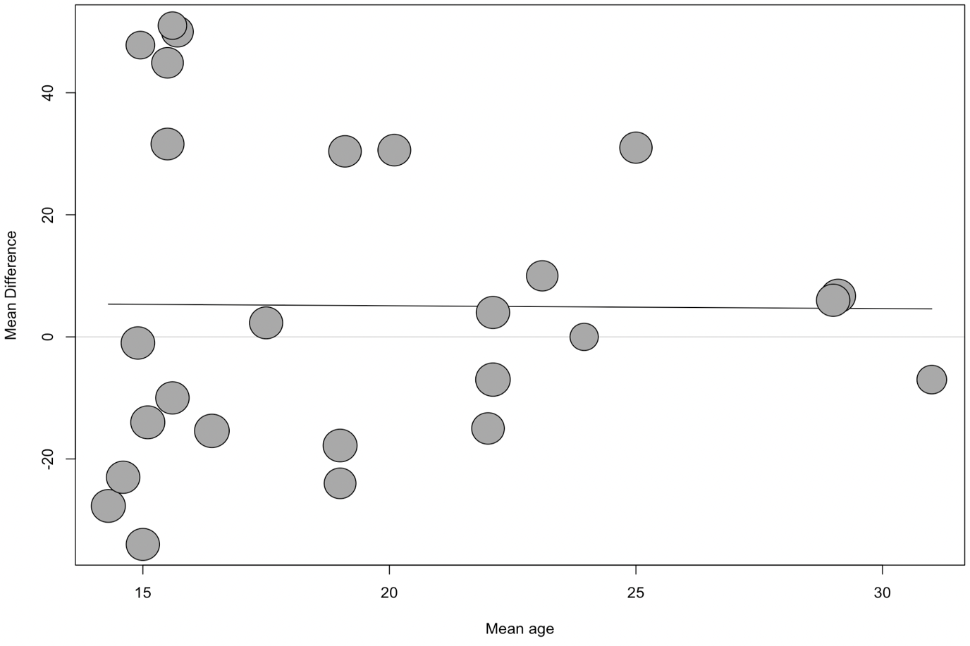
Regression co-efficient -0.046; p=0.965

Supplementary Figure 2: Meta-regression of duration of anorexia nervosa (AN) and mean difference in corrected QT interval (QTc) by Bazett formula
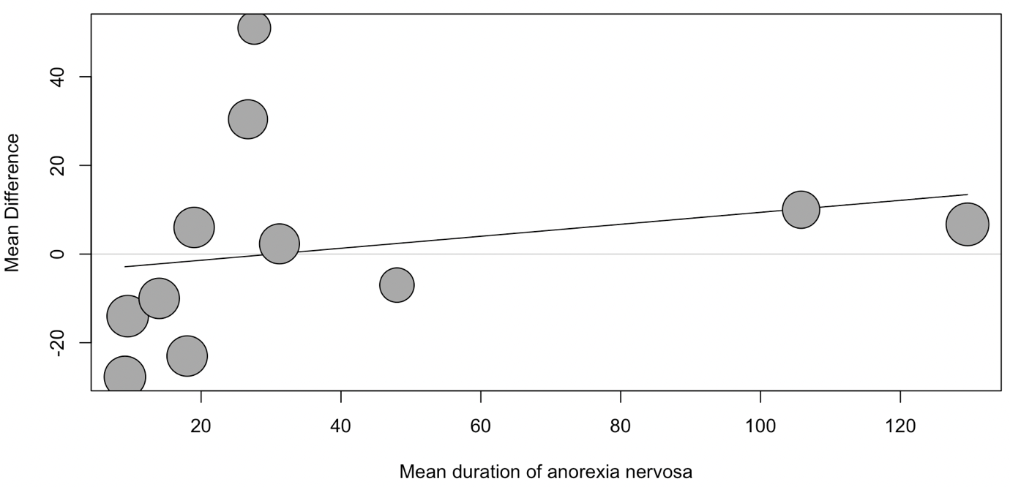
Regression co-efficient 0.135; p=0.426

Supplementary Figure 3: Meta-regression of body mass index (BMI) and mean difference in corrected QT interval (QTc) by Bazett formula
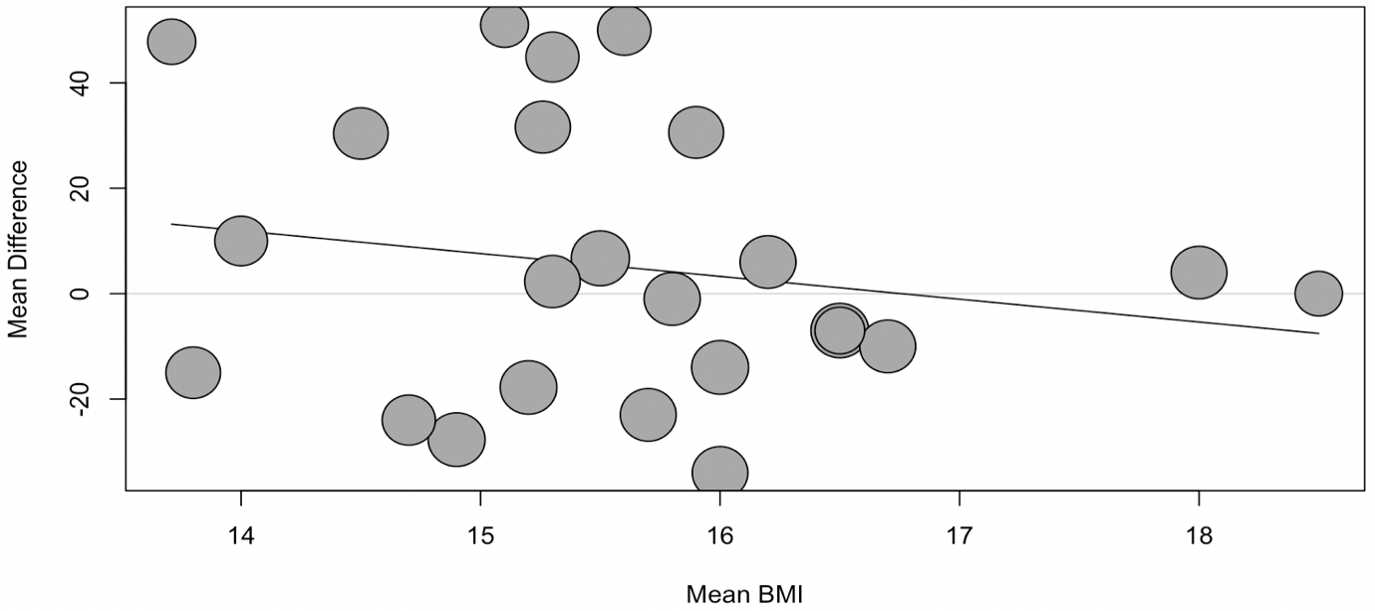
Regression co-efficient -4.33; p=0.364

Supplementary Figure 4: Meta-regression of heart rate (HR) and mean difference in corrected QT interval (QTc) by Bazett formula
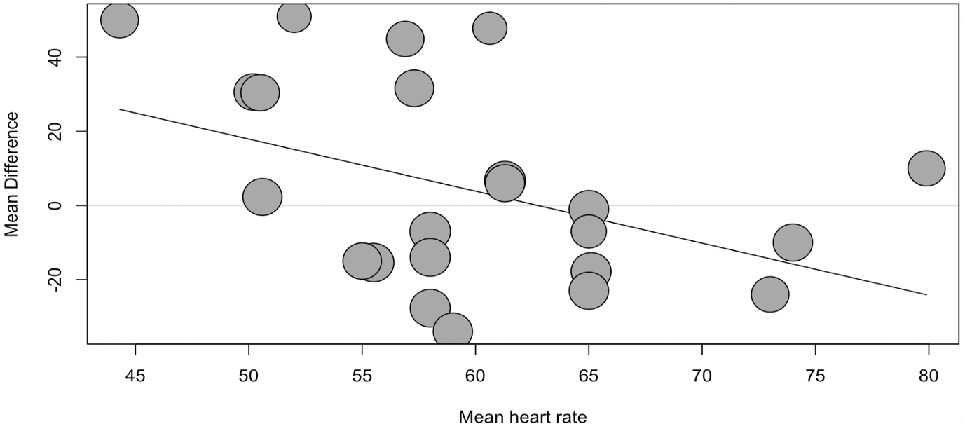
Regression co-efficient -1.41; p=0.025

Supplementary Figure 5: Forest plot of the QTc subgroup analysis categorized by AN severity based on BMI (mild: >17kg/m²; moderate: 16-16.9 kg/m²; severe: 15-15.9 kg/m²; extreme <15kg/m²)
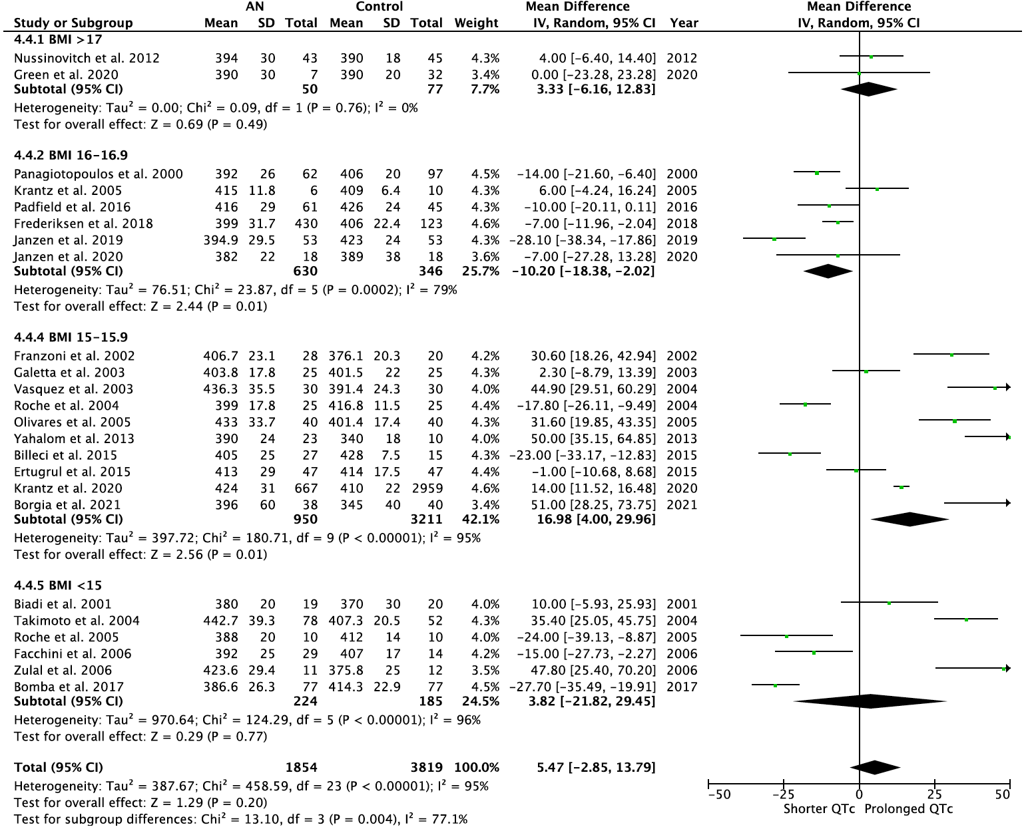
Abbreviations: AN – anorexia nervosa; BMI – body mass index; CI – confidence interval; QTc – corrected QT interval

Supplementary Figure 6: Forest plot of the QTc subgroup analysis categorized by age (above or below mean age of 19.7 years)
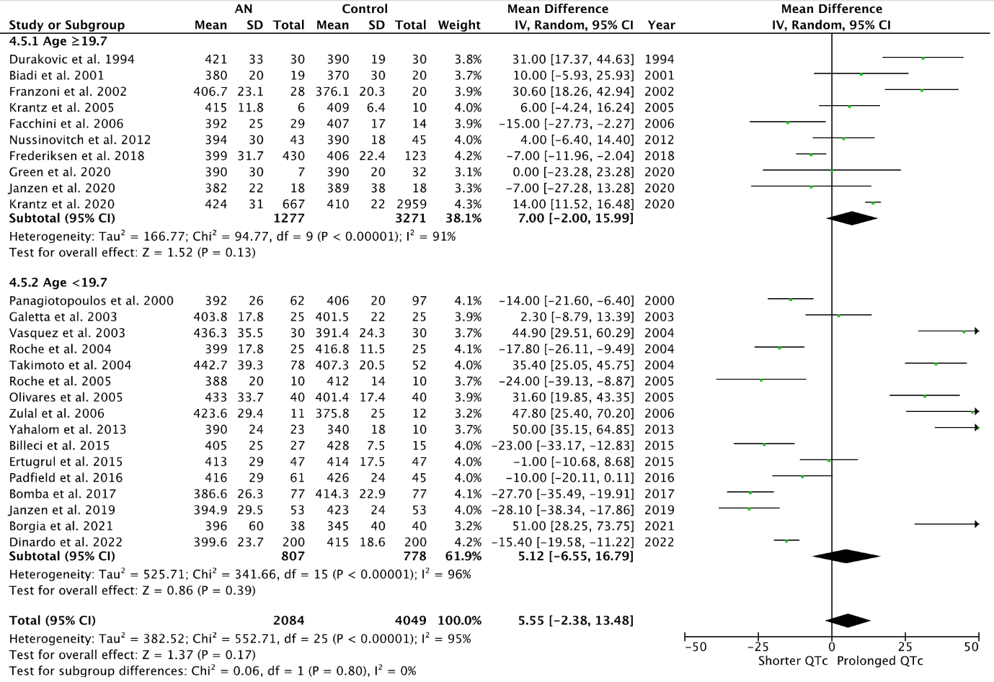

Supplementary Figure 7: Forest plot of the QTc subgroup analysis categorized by continent
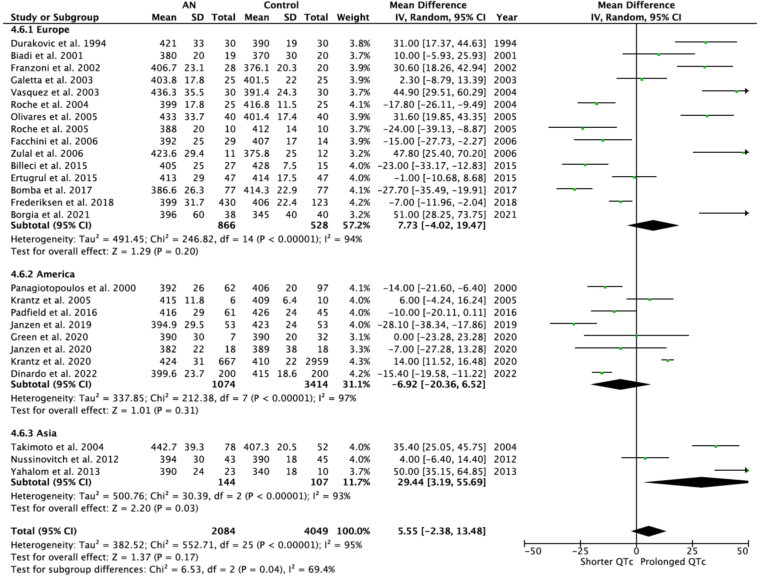

Supplementary Figure 8: Forest plot of the QTc subgroup analysis categorized by antipsychotic use
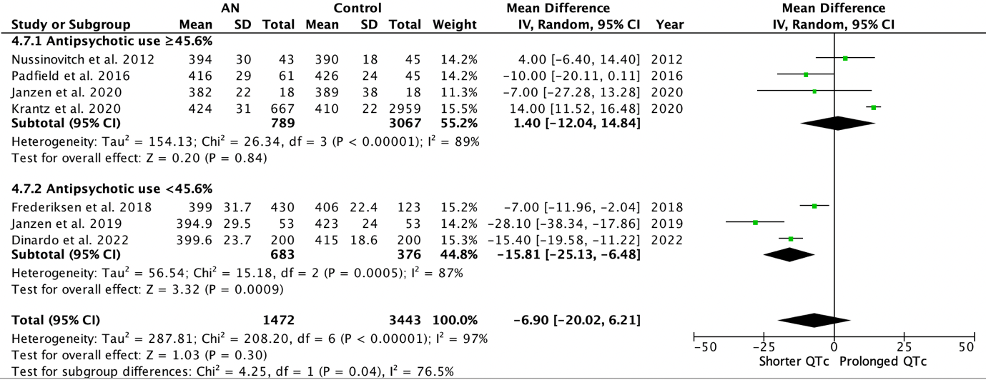

Supplementary Figure 9: Forest plot of the QTc subgroup analysis categorized by heart rate
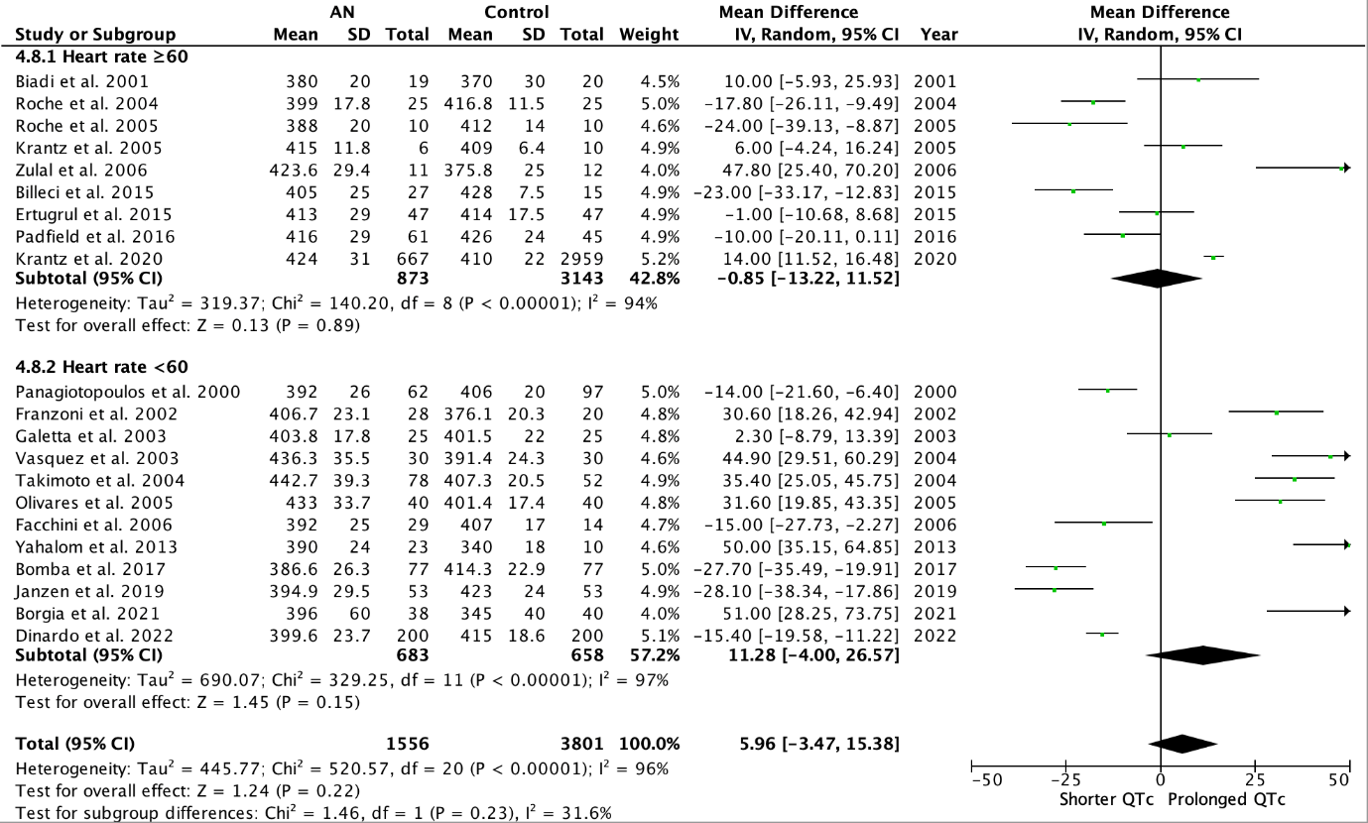

Supplementary Figure 10: Forest plot of the QTc subgroup analysis categorized by clinical setting
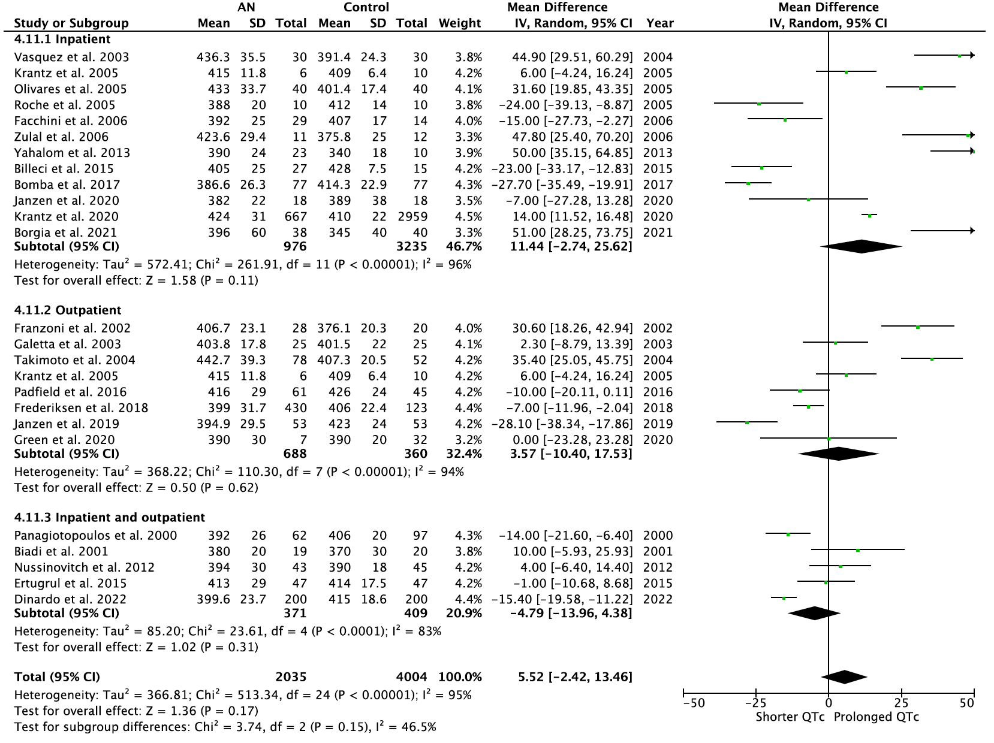

Supplementary Figure 11: Forest plot of the QT dispersion subgroup analysis categorized by body mass index (BMI)
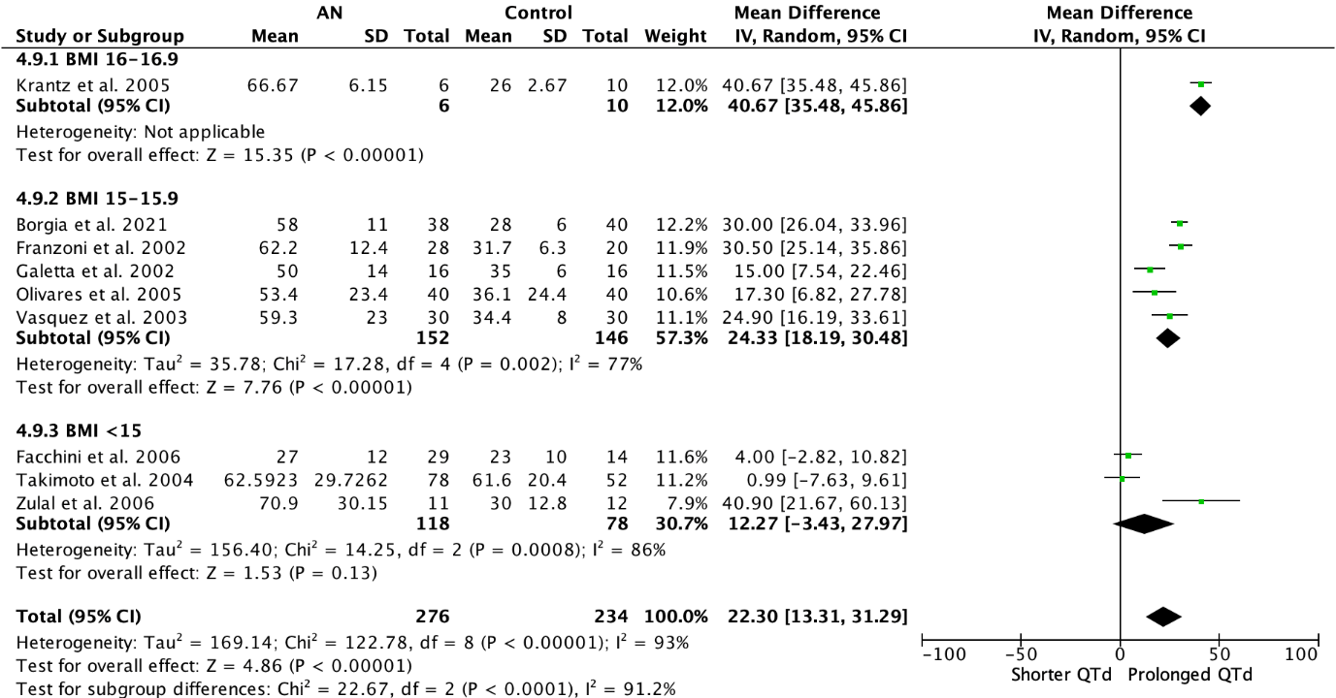

Supplementary Figure 12: Forest plot of the QTc dispersion subgroup analysis categorized by body mass index (BMI)
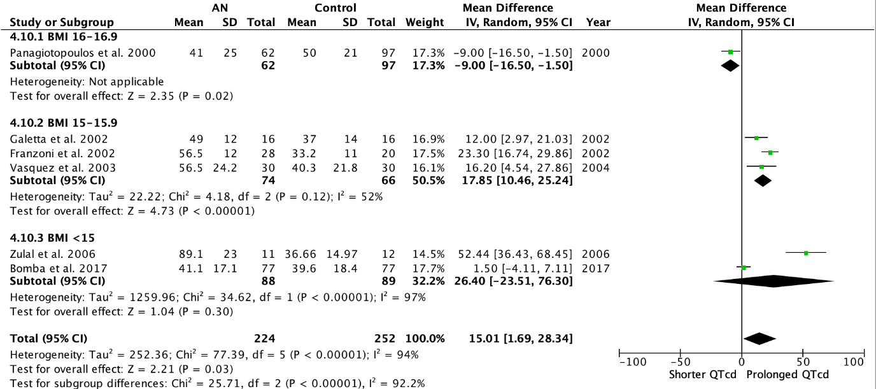

Supplementary Figure 13: Funnel plot of the studies comparing corrected QT interval (QTc) calculated by Bazett formula of anorexia nervosa patients and controls

